Online Electronic Applications Store Database

FIRST REVIEW REPORT

Submitted by

**Arpit Khurana (15BCE0353)**

Prepared For

**DATABASE SYSTEMS (CSE2004) – PROJECT COMPONENT**

Submitted To

**Ramanathan L**

**Assistant Professor (SG)**

**School of Computer Science and Engineering**



Table of Content

Introduction 3

Project Scope 3

Key Contacts 3

Project Resourses 4

E R Diagram 4

Tables and constraints 5

Work Breakdown 6

Review Evolution 6

# Introduction

E-commerce is fast gaining ground as an accepted and used business paradigm. More and more business houses are implementing web sites providing functionality for performing commercial transactions over the web. It is reasonable to say that the process of shopping on the web is becoming commonplace.

The objective of this project is to develop a general purpose e-commerce store database where electronic products like mobile, computers can be bought.

An online store is a virtual store on the Internet where customers can browse the catalog and select products of interest. The selected items may be collected in a shopping cart. At checkout time, the items in the shopping cart will be presented as an order. At that time, more information will be needed to complete the transaction. Usually, the customer will be asked to fill or select a billing address, a shipping address, a shipping option, and payment information such as credit card number. An e-mail notification is sent to the customer as soon as the order is placed.

# Project SCOPE

Online Electronic Application Store Database will do following processes

1. Any member can register and view available products
2. Only registered member can purchase multiple products regardless of quantity
3. There are three roles available: Visitor, User and Admin.
4. Visitor can view available products
5. User can view and purchase products.
6. An Admin has some extra privilege including all privilege of visitor and user. Admin can add products, edit product information and add/remove product.
7. Admin can add user, edit user information and can remove user.
8. The customer will be asked to fill or select a billing address, a shipping address, a shipping option, and payment information such as credit card number.
9. The bill will be given to the customer as soon as the order is placed.

# Key Contacts and Stakeholders

|  |  |  |
| --- | --- | --- |
| Name | Registration Number | Phone Number |
| ARPIT KHURANA | 15BCE0353 | 9335005977 |
|  |  |  |

# Project Resource Requirements

## Software Resource Requirements

* Windows XP (Service Pack3),7,8,8.1 or 10
* Mysql
* Java Jdk
* Java JVM
* JDBC Connector for my sql
* Eclipse IDE for JAVA

# ER Diagram

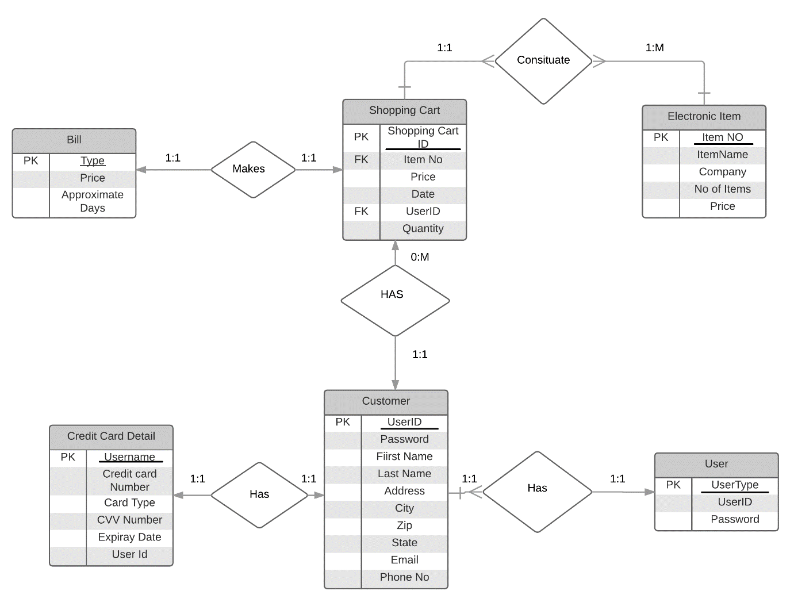

# Tables and Constraints

User

|  |  |  |  |
| --- | --- | --- | --- |
| SNO | NAME | TYPE | DESCRIPTION |
| 1 | User_Type | Varchar | Primary Key |
| 2 | User_Id | Varchar | Foreign Key |
| 3 | Password | Varchar |  |

Customer

|  |  |  |  |
| --- | --- | --- | --- |
| S NO | NAME | TYPE | DESCRIPTION |
| 1 | UserID | Varchar | Primary Key |
| 2 | Password | Varchar | Security |
| 3 | First_Name | Varchar |  |
| 4 | Last_Name | Varchar |  |
| 5 | Address | Varchar |  |
| 6 | City | Varchar |  |
| 7 | Zip | Integer |  |
| 8 | State | Varchar |  |
| 9 | Email_Address | Varchar |  |
| 10 | Phone_Number | Varchar |  |

Electronic Item

|  |  |  |  |
| --- | --- | --- | --- |
| SNO | NAME | TYPE | DESCRIPTION |
| 1 | Item_No | Varchar | Primary Key |
| 2 | Item_Name | Varchar |  |
| 3 | Company | Varchar |  |
| 4 | No of Items | Integer |  |
| 5 | Price | Double |  |

Shopping_Cart_Items

|  |  |  |  |
| --- | --- | --- | --- |
| S_NO | Name | Type | Description |
| 1 | Shopping_Cart_Id | Integer | Primary Key |
| 2 | Item_No | Varchar | Foreign Key |
| 3 | Price | Doubl |  |
| 4 | Date | Date |  |
| 5 | UserID | Varchar | Foreign Key |
| 6 | Quantity | Integer |  |

Bill

|  |  |  |  |
| --- | --- | --- | --- |
| SNO | NAME | Type | DESCRIPTION |
| 1 | Type of Shipping | Varchar | Primary Key |
| 2 | Price | Double |  |
| 3 | Approximate days | Integer |  |

Credit Card Details

|  |  |  |  |
| --- | --- | --- | --- |
| SNO | NAME | TYPE | DESCRIPTION |
| 1 | Credit Username | Varchar | Primary Key |
| 2 | Credit Card Number | Varchar |  |
| 3 | Card Type | Varchar | Master card , Visa |
| 4 | CVV Number | Interger |  |
| 5 | Expiry Date | Date |  |
| 6 | UserID | Varchar | Foreign Key |

# Work break down

|  |  |  |
| --- | --- | --- |
| **Team Member Registration Number** | **Name** | **Work Assigned** |
| 15BCE0353 | ARPIT KHURANA | Complete Project |

# REVIEW EVALUATION

|  |  |  |  |  |  |  |
| --- | --- | --- | --- | --- | --- | --- |
| COMPONENT | MARKS | MEMBER 1 | MEMBER 2 | MEMBER 3 | MEMBER 4 | MEMBER 5 |
| LITERATURE SURVEY | 10 |  |  |  |  |  |
| ER DIAGRAM | 10 |  |  |  |  |  |
| CONSTRAINTS | 10 |  |  |  |  |  |
| TOTAL | 30 MARKS |  |  |  |  |  |